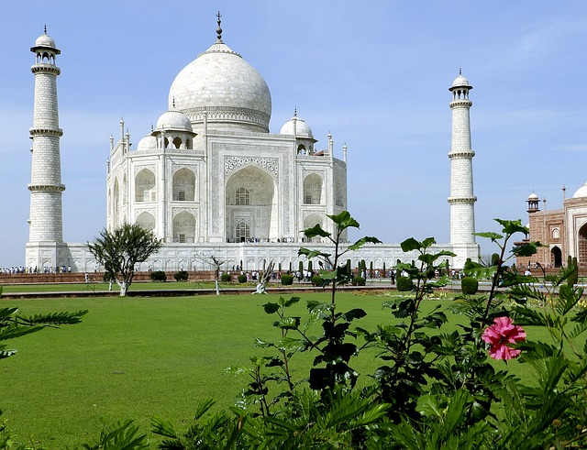

Taj Mahal

The Taj Mahal is one of the most renowned and beautiful monuments in the world. It is located in Agra, India, and is celebrated for its stunning architecture and the love story behind its creation. Here's a brief history of the Taj Mahal in 8 points:

**1. Construction Date (17th Century):** The Taj Mahal was built in the 17th century, with construction commencing in 1632 and completing in 1648. It was commissioned by the Mughal Emperor Shah Jahan in memory of his favorite wife, Mumtaz Mahal, who died during childbirth in 1631.

**2. Architectural Style:** The Taj Mahal is a masterpiece of Mughal architecture, blending elements from Persian, Islamic, and Indian architectural styles. It is renowned for its symmetrical design, white marble facade, and intricate decorations.

**3. Architect and Artisans:** The chief architect of the Taj Mahal was Ustad Ahmad Lahori. Thousands of artisans and laborers from various parts of the Mughal Empire and beyond were involved in its construction.

**4. Materials:** The main material used for the construction of the Taj Mahal is white marble, which was quarried from the nearby Makrana quarries in Rajasthan. Precious and semi-precious stones were also used to create intricate inlay work.

**5. Mumtaz Mahal:** The Taj Mahal was built as a mausoleum to house the tomb of Mumtaz Mahal. Her body was initially interred in a temporary tomb, and later, her remains were moved to the Taj Mahal.

**6. Shah Jahan's Imprisonment:** Shah Jahan, the emperor who commissioned the Taj Mahal, was deposed and imprisoned by his son Aurangzeb in the Agra Fort, from where he could see the Taj Mahal but was unable to visit it. He spent the final years of his life in captivity.

**7. Historical Significance:** The Taj Mahal is a UNESCO World Heritage Site and is often considered one of the most beautiful buildings in the world. It has become a symbol of enduring love and is a testament to the rich cultural heritage of India.

**8. Tourist Attraction**: The Taj Mahal attracts millions of tourists from around the world every year. It is not only admired for its architectural beauty but also for the poignant love story that inspired its creation.

The Taj Mahal stands as a remarkable testament to the power of love and the artistic achievements of the Mughal Empire. It remains an enduring symbol of India and a marvel of architectural and artistic excellence